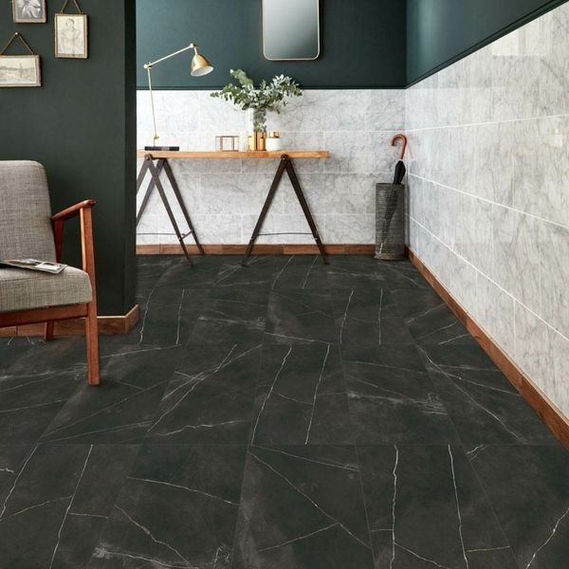

Belgravia Matt Abanilla Marble Effect Tiles: https://www.wallsandfloors.co.uk/belgravia-matt-abanilla-marble-effect-tiles

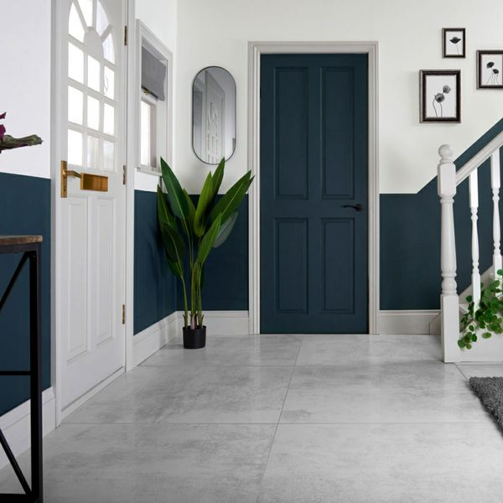

Cosmic Cloud White Lappato Floor Tiles: <https://www.wallsandfloors.co.uk/cosmic-cloud-white-lapato-898x898>

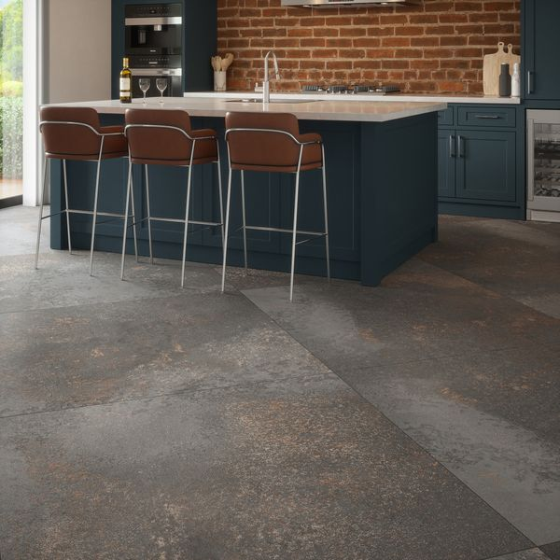

Yuri™ Graphite 90% Recycled 1175x1175 Tiles: <https://www.wallsandfloors.co.uk/yuri-graphite-90-recycled-1175x1175-tiles>

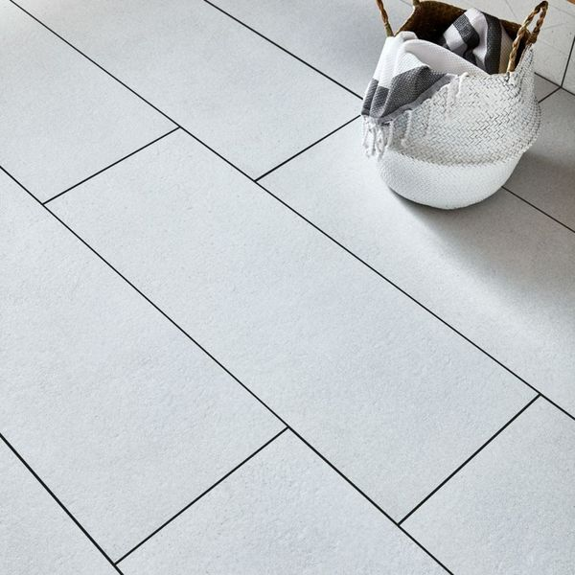

Largo Mist White Tiles: https://www.wallsandfloors.co.uk/largo-mist-tiles